

AP® Physics C
1976 Free Response Questions

The materials included in these files are intended for use by AP teachers for course and exam preparation in the classroom; permission for any other use must be sought from the Advanced Placement Program®. Teachers may reproduce them, in whole or in part, in limited quantities, for face-to-face teaching purposes but may not mass distribute the materials, electronically or otherwise. These materials and any copies made of them may not be resold, and the copyright notices must be retained as they appear here. This permission does not apply to any third-party copyrights contained herein.

These materials were produced by Educational Testing Service® (ETS®), which develops and administers the examinations of the Advanced Placement
Program for the College Board. The College Board and Educational Testing Service (ETS) are dedicated to the principle of equal opportunity, and their
programs, services, and employment policies are guided by that principle.

The College Board is a national nonprofit membership association dedicated to preparing, inspiring, and connecting students to college and opportunity.
Founded in 1900, the association is composed of more than 4,200 schools, colleges, universities, and other educational organizations. Each year, the
College Board serves over three million students and their parents, 22,000 high schools, and 3,500 colleges, through major programs and services in
college admission, guidance, assessment, financial aid, enrollment, and teaching and learning. Among its best-known programs are the SAT®, the
PSAT/NMSQT®, and the Advanced Placement Program® (AP®). The College Board is committed to the principles of equity and
excellence, and that commitment is embodied in all of its programs, services, activities, and concerns.

APIEL is a trademark owned by the College Entrance Examination Board. PSAT/NMSQT is a registered trademark jointly owned by the College Entrance Examination Board and the National Merit Scholarship Corporation. Educational Testing Service and ETS are registered trademarks of Educational Testing Service.
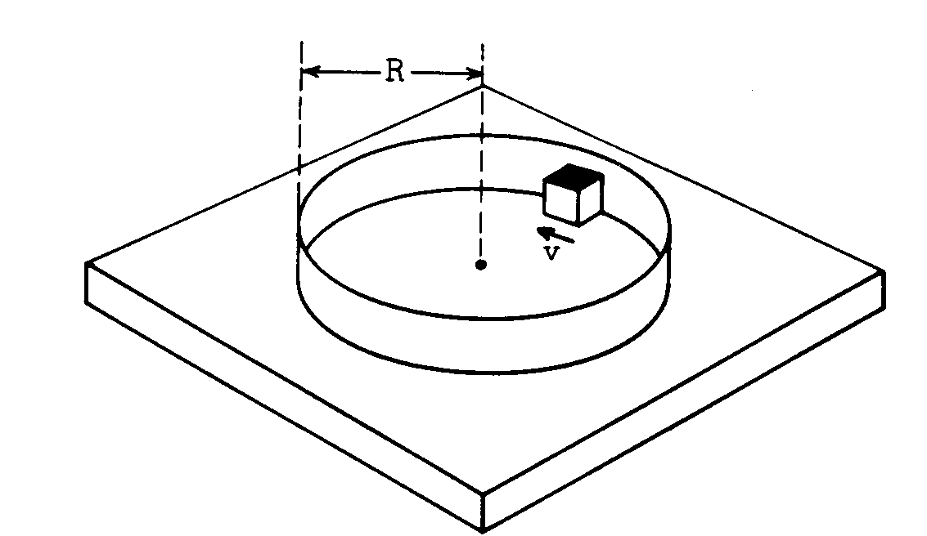
1976M1. A small block of mass m slides on a horizontal frictionless surface as it travels around the inside of a hoop of radius R. The coefficient of friction between the block and the wall is μ; therefore, the speed v of the block decreases. In terms of m, R. μ, and v, find expressions for each of the following.
a. The frictional force on the block
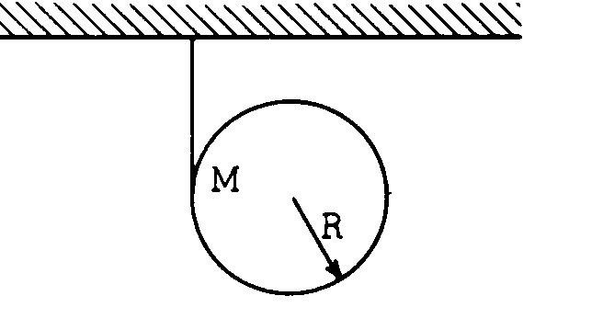
b. The block's tangential acceleration dv/dt
c. The time required to reduce the speed of the block from an initial value v₀ to v_{o}/3
1976M2. A cloth tape is wound around the outside of a uniform solid cylinder (mass M, radius R) and fastened to the ceiling as shown in the diagram above. The cylinder is held with the tape vertical and then released from rest. As the cylinder descends, it unwinds from the tape without slipping. The moment of inertia of a uniform solid cylinder about its center is ½MR².
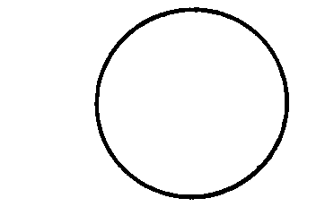
a. On the circle below draw vectors showing all the forces acting on the cylinder after it is released. Label each force clearly.
b. In terms of g, find the downward acceleration of the center of the cylinder as it unrolls from the tape.
c. While descending, does the center of the cylinder move toward the left, toward the right, or straight down? Explain.
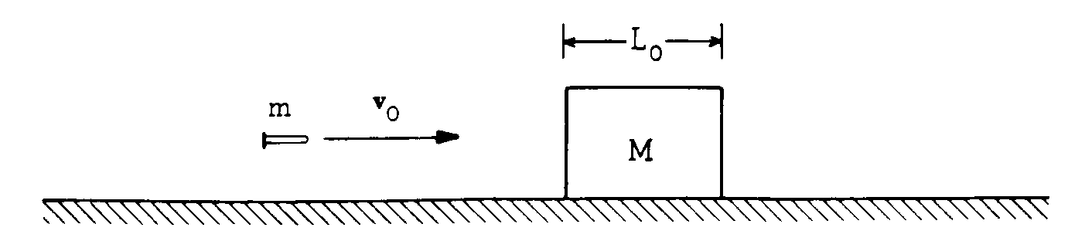
1976M3. A bullet of mass m and velocity v_{o} is fired toward a block of thickness L_{o} and mass M. The block is initially at rest on a frictionless surface. The bullet emerges from the block with velocity v_{o}/3.
a. Determine the final speed of block M.
b. If, instead, the block is held fixed and not allowed to slide, the bullet emerges from the block with a
speed v_{o}/2. Determine the loss of kinetic energy of the bullet
c. Assume that the retarding force that the block material exerts on the bullet is constant. In terms of L_{o}, what minimum thickness L should a fixed block of similar material have in order to stop the bullet?
d. When the block is held fixed, the bullet emerges from the block with a greater speed than when the block is free to move. Explain.

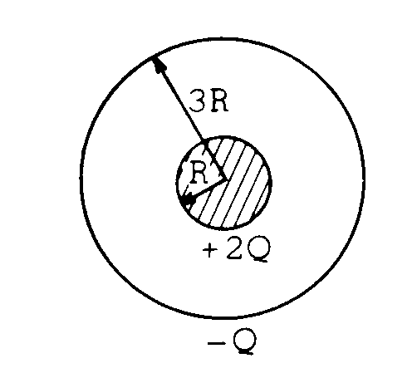
1976E1. A solid metal sphere of radius R has charge +2Q. A hollow spherical shell of radius 3R placed concentric with the first sphere has net charge -Q.
a. On the diagram below, make a sketch of the electric field lines inside and outside the spheres.

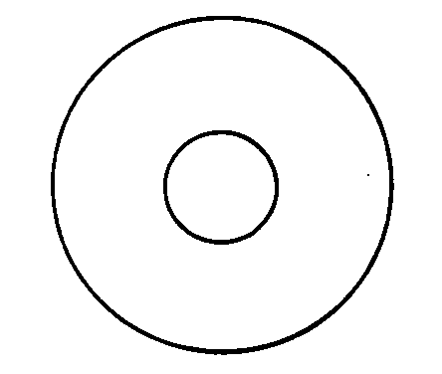
b. Use Gauss's law to find an expression for the magnitude of the electric field between the spheres at a distance r from the center of the inner sphere (R < r < 3R).
c. Calculate the potential difference between the two spheres.
d. What would be the final distribution of the charge if the spheres were joined by a conducting wire?
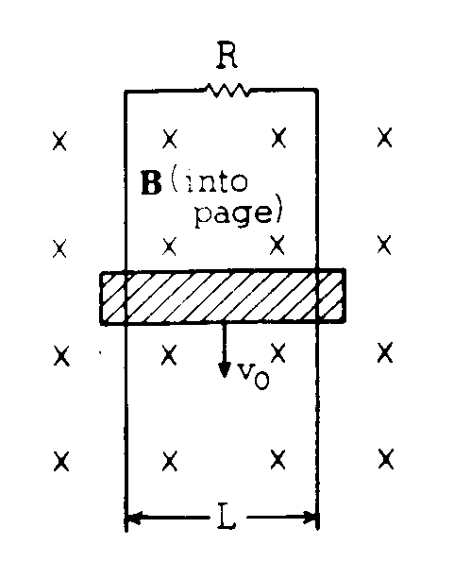
1976E2. A conducting bar of mass M slides without friction down two vertical conducting rails which are separated by a distance L and are joined at the top through an unknown resistance R. The bar maintains electrical contact with the rails at all times. There is a uniform magnetic field B, directed into the page as shown above. The bar is observed to fall with a constant terminal speed v₀.
a. On the diagram below, draw and label all the forces acting on the bar.


b. Determine the magnitude of the induced current I in the bar as it falls with constant speed v₀ in terms of B, L, g, v₀, and M.
c. Determine the voltage induced in the bar in terms of B, L, g, v₀, and M.
d. Determine the resistance R in terms of B, L, g, v₀, and M.

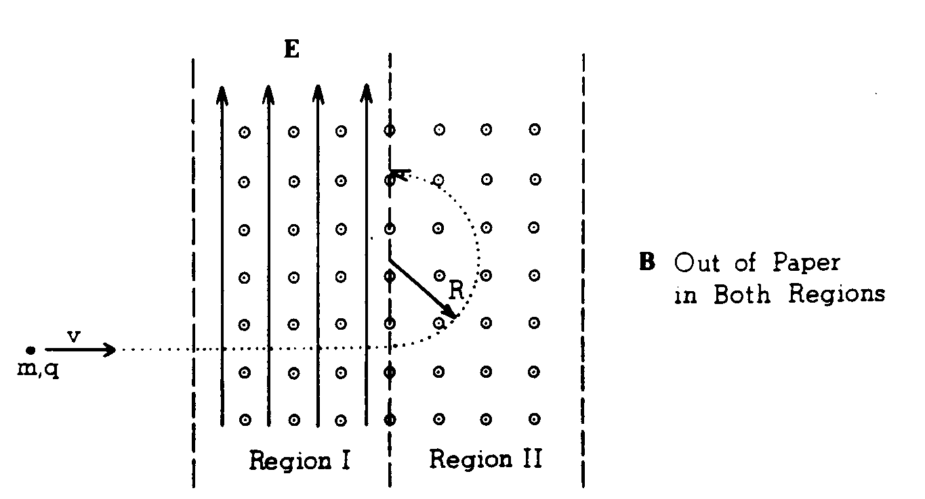
1976E3. An ion of mass m and charge of known magnitude q is observed to move in a straight line through a region of space in which a uniform magnetic field B points out of the paper and a uniform electric field E points toward the top edge of the paper, as shown in region I above. The particle travels into region II in which the same magnetic field is present, but the electric field is zero. In region II the ion moves in a circular path of radius R as shown.
a. Indicate on the diagram below the direction of the force on the ion at point P₂, in region II.

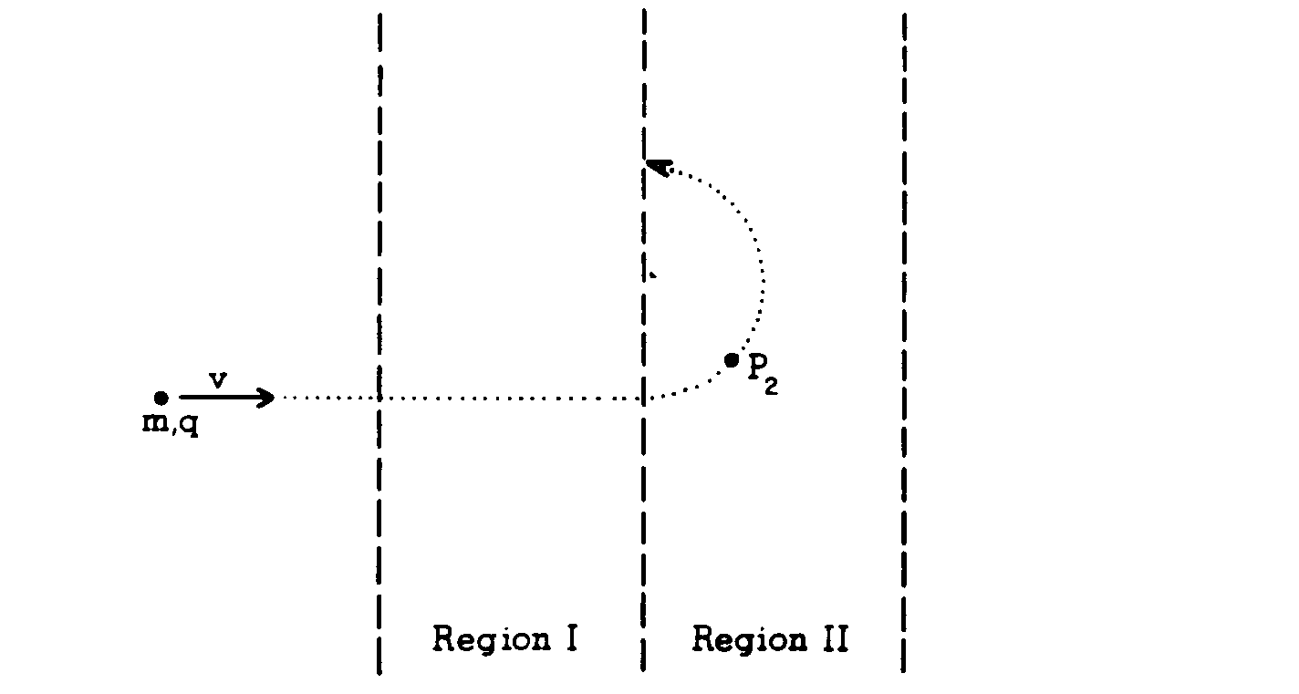
b. Is the ion positively or negatively charged? Explain clearly the reasoning on which you base your conclusion.
c. Indicate and label on the diagram below the forces which act on the ion at point P₁ in region I.
P₁
d. Find an expression for the ion’s speed v at point P₁ in terms of E and B.
e. Starting with Newton’s law, derive an expression for the mass m of the ion in terms of B, E, q, and R.

